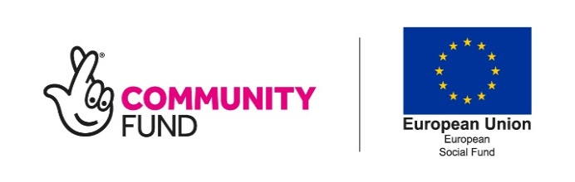
Building Better Opportunities
Support into Employment
Referral Form

BBO Support into Employment

Client’s Eligibility Criteria:
Person experiencing/ experienced mental ill-health | YES / NO
UK resident and legal right to work in the UK | YES / NO
Employment Status:
Participants who are registered unemployed (PLEASE HIGHLIGHT)  (In receipt of unemployment benefits, JSA, ESA work related, UC LWCG) |  |  |  | YES / NO
Participants who are economically inactive (PLEASE HIGHLIGHT)  (Out of work and not available or not actively seeking work: ESA support group, UC LWCGRA or parental responsibilities/carers/ students) |  |  |  | YES / NO
Please state your employment status:
Parental responsibilities / Caring responsibilities / Student
Personal Background Information:
Name
Address
 |  | Post Code
Telephone No. |  | Mobile No.
Email
Date of Birth |  | NI No.

What are your main expectations for working with the project?
(aims and goals)
Are you interested in attending the ‘Bridging the Gap’ – Step Towards Employability Course?
Do you require any specific requirements to attend interviews or reviews?
Please Specify:
Asian/Asian British:  Indian  Pakistani  Bangladeshi  Chinese  Other background  Other Ethnic group:  Arab  Other background | Dual heritage:  White and Black Caribbean  White and Black African  White Asian  Other background  Black/Black British  Caribbean  African  Other background | White:  British  English  Northern Irish  Scottish  Welsh  Irish  Gypsy, Irish Traveller or Roma  Other background
Tick one category that you feel best describes your ethnic origin, if you would prefer not to give your ethnicity please tick here :

In order for participants to be eligible for support on the BBO Support into Employment programme, certain types of evidence must be obtained, these include: Birth certificate or passport and Official letter stating employment status and Self-declaration. A full list will be made available on the 1st contact meeting.
Please send all referrals to:

Nikki Parrott – Project Co-Ordinator
Mobile: 07546093379 Email: Nikki@Northamptonmind.org.uk

Northampton and District Mind
6-7 Regent Square
Northampton
NN1 2NQ

Self-Referral |  | YES / NO | Organisational Referral | YES / NO
Name/Contact details

Signature of referrer

Date of Referral

The Building Better Opportunities: Support into Employment Programme is funded by the National Lottery Community Fund and the European Social Fund

